Task 1
Analyse this film poster for Jakob’s Wife in terms of how it communicates meaning about the narrative and genre.

Consider the following points:
- Colour
- Symbols
- Costumes
- Facial expression
- Body language
- Setting
- Make up/hair
- Text including font type
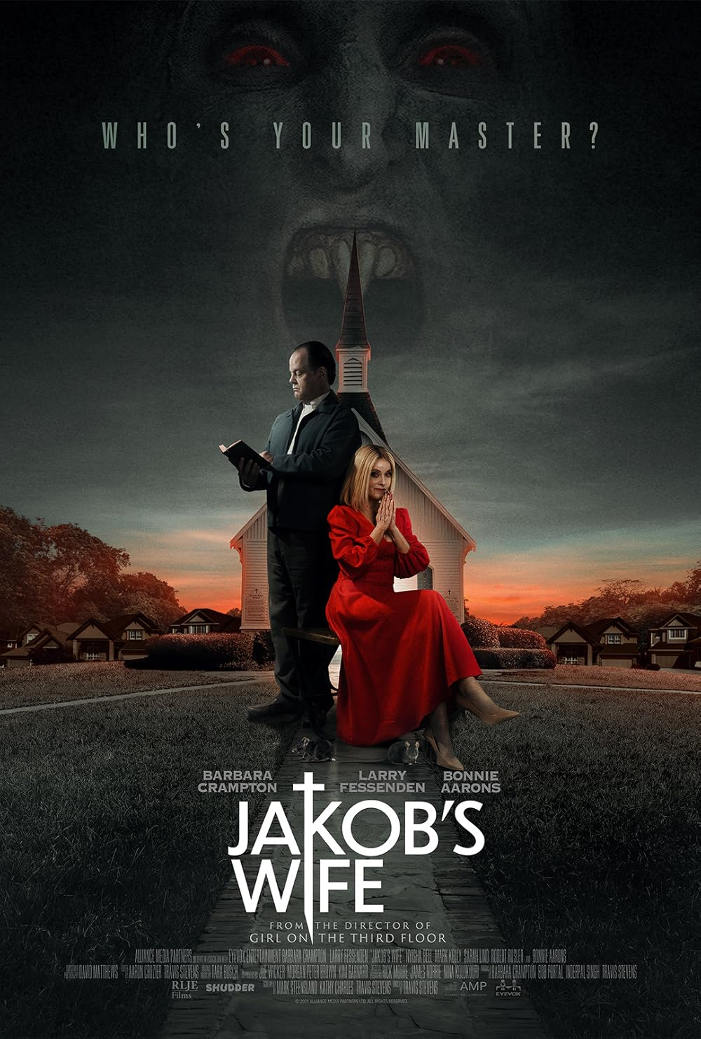

Task 2
Use your knowledge of colour, structure, and layout to design a film poster for a new vampire film utilising genre conventions.

Your poster must include:
- Title (come up with your own)
- Tagline
- Star names
- Main image and setting

