Cheshire College South and West – A-Level Geography Bridging Work


A-Level Topics Studied - AQA A-level Geography 7037 | Specification | Specification At A Glance | AQA
A1 – Coastal Systems and Landscapes, Contemporary Urban Environments, and Changing Places
A2 – Hazards, Water and Carbon Cycles, and Global Systems and Global Governance
Non-Exam Assessment (20%) – Geographical Fieldwork Investigation

Bridging Tasks:
- Watch the news, across a variety of sources, over the summer and keep a record of events which you deem geography related. These might be news stories related to climate change, resource security, or urbanisation for example. For each event, summarise and explain why it is a geographical issue. Classify the event/its impacts as social, political, economic, environmental or demographic – try to find at least one event linking to each of the five listed categories. This could be presented in a Word document, including a screenshot of the article.
Environment | The Guardian | Global development | The Guardian | Climate crisis | The Guardian
Climate | Latest News & Updates | BBC News | World | Latest News & Updates | BBC News
- Choose a documentary from the two linked below. Summarise the main geographical issues, considering how human interaction with the natural world impacts places and environments
The Americas with Simon Reeve The World’s Dirtiest Air (Unreported World)
The Americas with Simon Reeve - BBC iPlayer Unreported World - Series 13: Episode 2 | Channel 4
- Review GCSE topic ‘Coasts’ – make a glossary of the key terms from GCSE. You may use the following resources as a starting point:
Coastal landscapes in the UK - GCSE Geography - BBC Bitesize
Coastal landscapes KS4 | Y10 Geography Lesson Resources | Oak National Academy
- Research the physical and human geography of the Sundarbans, as this will be our main coastal case study beyond the UK. Aim to understand where the Sundarbans are, alongside why the environment is under threat.
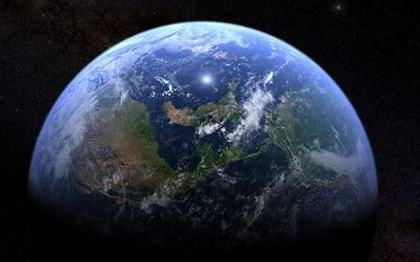

https://www.channel4.com/programmes/unreported-world/on-demand/6719

