A Level English Literature

Course information and summer bridging task

Contents
Why choose English Literature at A Level?
Course content & information
1st year reading list
Summer bridging task – The Great Gatsby

Why choose English Literature at A Level?
English Literature is a varied, rewarding subject at A Level. We cover a range of poems, plays and novels spanning the 16th to 21st centuries, so no two terms are ever the same! Literature students will get the opportunity to read, research, discuss and analyse texts in the classroom and independently.
At CCSW, Literature students often undertake study programmes involving other humanities or arts subjects, progress to further study at university and then on to careers in fields as diverse as education, the media and the law.
Course content
Year 1
September - December
- Introduction to English Literature at A Level – developing key skills for success
- The Great Gatsby by F. Scott Fitzgerald & The Road by Cormac McCarthy
January – March
- Introduction to drama in the Elizabethan era
- Doctor Faustus by Christopher Marlowe
- Prose Study coursework planning and drafting
April – June
- Introduction to poetry analysis
- Selected Poems by Sylvia Plath & Poems Selected by Simon Armitage by Ted Hughes.
- Preparation for second year content
- Submission of Prose Study coursework component
Course information
Exam board: Eduqas
Subject name: English Literature A Level
Course code: A720QS A Level
Assessment: 3x 2hr exams (Poetry, Drama, Unseen Texts) & 1x Prose study coursework essay (2500-3500 words) undertaken in second year of study.

1st Year reading list (in order of study)
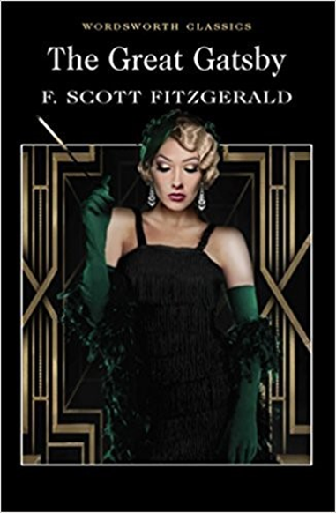 | The Great Gatsby  F. Scott Fitzgerald  ISBN: 9781853260414  (Wordsworth Classic preferable for page no. consistency)
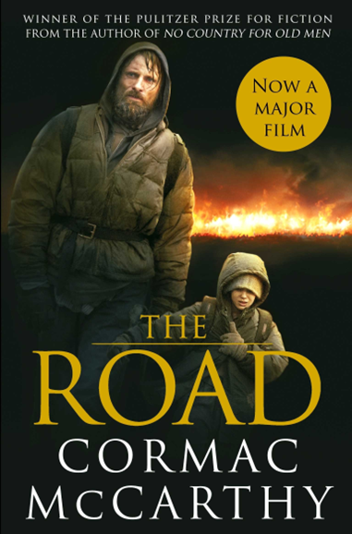 | The Road  Cormac McCarthy  ISBN: 9780330468466  (Picador preferable for page no. consistency)
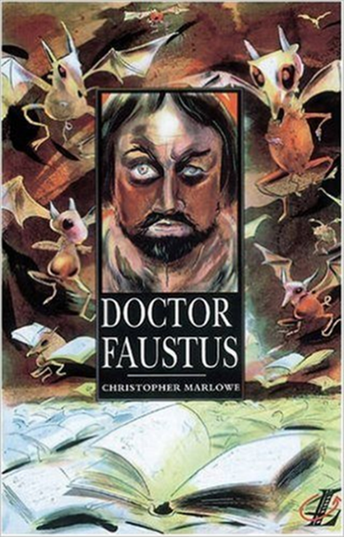 | Doctor Faustus  Christopher Marlowe  ISBN: 9780582254091  (MUST be the Longman Text B – specified by the exam board)
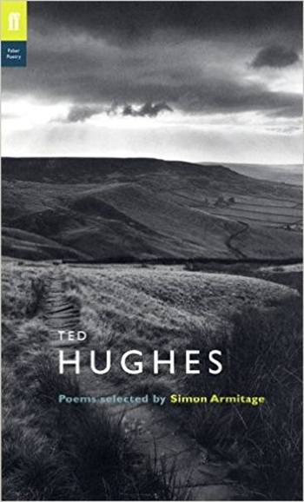 | Poems selected by Simon Armitage  Ted Hughes  ISBN: 97780571222957  (Faber)
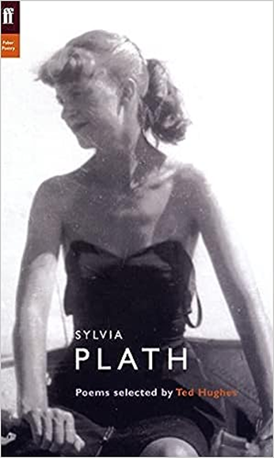 | Selected Poems  Sylvia Plath  ISBN: 9780571135868  (Faber)

English Literature Welcome Day – Summer bridging task

Ahead of the start of your course in September, you should have read the whole of The Great Gatsby by F. Scott Fitzgerald.
As you read the novel, answer the following questions. Bring this bridging task back with you to the first lesson of the year.

- In which US city is the majority of The Great Gatsby set?

- Who is Nick Carraway?

- What links Nick with Daisy and Tom Buchanan?

- What sport does Jordan Baker play?

- What sort of business does George Wilson run?

- Which breed of dog does Myrtle Wilson believe she has bought?

- What sort of an artist is Mr McKee?

- Why does Myrtle believe Tom can’t divorce Daisy?

- How many crates of fruit does Gatsby buy for his parties?

- What colour is Gatsby’s car?

- Which country does Gatsby claim gave him a medal ‘For Valor Extraordinary’?
- What sporting event did Meyer Wolfsheim ‘fix’ in 1919?

- How much were the pearls Tom gave Daisy worth?

- What item of Gatsby’s clothing does Daisy cry over?

- What is Gatsby’s real name?

- What is the name of the alcoholic millionaire who takes Gatsby round the world on his boat?

- Why does Gatsby fire his servants?

- Which hotel do Gatsby, Nick, Daisy, Tom and Jordan go to in chapter 7?

- How does Myrtle Wilson die?

- Which of Gatsby’s party guests is the only person to attend his funeral?

Judging a book by its cover
The novel’s first edition was published by Scribner’s in 1925, and had a front cover designed by Francis Cugat. What does Cugat’s artwork suggest about the:
- Setting
- Characters
- Plot
of The Great Gatsby?
Annotate the front cover on the next page, identifying the aspects you feel reveal details about the novel to a prospective reader.
