A-level English Language

Bridging the gap between GCSE and A-level



The tasks in this pack are designed to give you an insight into studying English Language.

Please complete activities 1-5 to the best of your ability and bring them to your first lesson in September. They are designed to help you understand some of the main topics you will study in the next two years.

1. Text Analysis
One of the main parts of the course is language analysis. You won’t be studying heavy, serious books, but instead will explore all kinds of language, looking at how it is spoken, written and texted! You will study a range of texts about various subjects, for various audiences and purposes, in a variety of modes (written, spoken, electronic), from different times and from different places.
When analysing texts, you will explore how language is shaped according to audience, purpose, genre and mode and used to construct meanings and representations.
To help prepare for this, take a quick look at each of the following texts and consider:
  - What is the topic?
  - What might the text be trying to convey — what ideas, messages, opinions, or personalities come through?
  - How does it use different communication tools, such as design, colour, word choice, structure, style, and interaction?
Jot down some brief notes in the table below about how each text compares in its language use. How formal/informal are they? What audience are they trying to reach? Is there anything interesting in the word choices that is influenced by the fact they are written/spoken?

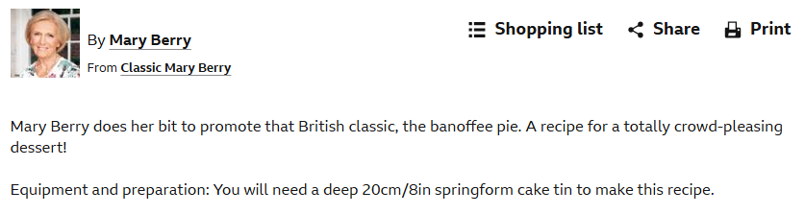
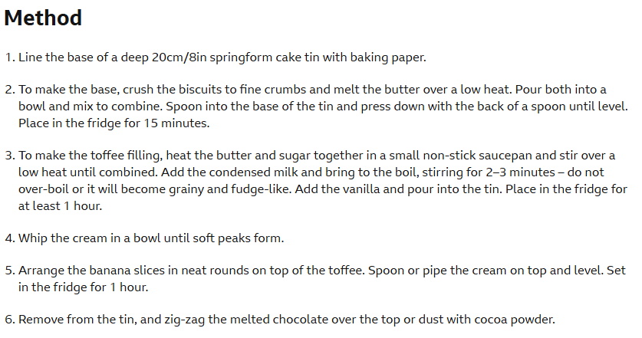
Recipe for banoffee pie from BBC ‘Good Food’ website
Part of a radio commentary on a live football match

And it’s controlled beautifully by Jack Harrison who beats his man and whips a ball across the face of goal. It’s an inviting ball and it’s Ben White who gets on the end of it to put it past the keeper’s outstretched hand. First goal of the season for the central defender and what a great team goal that was

An Instagram post from an ‘influencer’




Charity poster displayed in an underground railway station


The small text reads: “Stima does everything she can for her little boy, as any mother would. But when there’s only dirty water to drink, when it’s deadly, disease-ridden water or nothing – all the love in the world can’t keep him safe. £3 from you can.”

2. Language Profile
One of the most fascinating parts of studying language is discovering more about your own language use - so this task is all about you.
Create a ‘language profile’ by answering the following questions and summarising your responses. This can be done as a mind map, list of notes or in any exciting way you choose! You will need to bring this with you on your first week.
Focus on the most interesting and significant aspects of how you use language:
- What is your earliest memory of language? Can you recall a favourite nursery rhyme, song, or picture book from early childhood? Do you know, or can you find out, what your first word was? Has your family or extended family kept any records (such as videos, audio clips, or shared memories) of your first words?
- Where were you born, and where are your family members from, whether in the UK or beyond? Have you ever lived somewhere else?
- Looking back a few generations, are there any other languages spoken in your family, or have family members lived in different parts of the world?
- Are there any unique words or phrases that only you or your family use, which others might not understand?
- Do you or your friends at school use language in ways that stand out from those around you, such as your teachers, family, or other students?
- Are there any people on TV, online, in films, or in music videos whose way of speaking interests or even irritates you?
Language is much more than just words on a page, so keep these ideas in mind to explore its full range. We are often taught that there is a ‘right’ and ‘wrong’ way to use language, but the more you study it, the more you’ll realize that language is far more complex and intriguing. Over time, you’ll develop a deeper understanding of the different influences that shape your own language identity and how you can adapt your language use in different situations.

3. Language Fingerprints
As you study language, you’ll notice everyone has a distinctive way of speaking and writing, shaped by factors like background, age, profession, interests, and personality. This unique style is called an idiolect. Though not as precise as a fingerprint, it’s similar in that forensic linguists can analyse language patterns to help identify a person’s identity or background.
In this activity, you’ll take on the role of a language detective. A local college needs your expertise to determine who might have sent a threatening note to a teacher. With three suspects, your task is to analyse possible linguistic clues and provide your opinion on which suspect is most likely responsible.
The Case of the Threatening Note: A Forensic Linguistics Challenge
Background: A threatening note was found in a teacher's office at Cowes Enterprise College. The Headteacher has narrowed down the suspects to three individuals based on their recent conflicts with the teacher. Your task is to use forensic linguistics to determine which suspect likely wrote the note.
Instructions:
- Analyse the Note: Carefully examine the threatening note, focusing on linguistic features such as word choice, sentence structure, punctuation, and tone.
- Compare with Suspect Profiles: Compare the note's linguistic features with the writing samples provided by each suspect. Consider how each suspect’s writing style and language use might match or differ from the note.
- Identify the Suspect: Write a short paragraph explaining who you think the culprit is, and what linguistic evidence you have got for this.
The Threatening Note:
YOU WILL REGRET YOUR DECISION. THIS IS JUST THE BEGINNING. WATCH OUT!
Note Details:
- Written in: Black ink, printed in uppercase letters
- Punctuation: what can you comment on?
- Language Style: what can you comment on?
Suspect Profiles and Writing Samples
Suspect 1: Alex Morgan
Profile:
Alex is a quiet student who prefers to keep to themselves. They often communicate via text messages or emails, preferring brief communication. Alex was recently reprimanded by the teacher for not participating in group work, which they found unfair.
Writing Sample:
"Group work is not for everyone. I did not think it was fair to be singled out, but I will try to do better next time."
Suspect 2: Jamie Turner
Profile:
Jamie is a sixth form student known for being outspoken in class discussions. They often express their opinions strongly, especially when they feel an injustice has occurred. Jamie recently had a heated argument with the teacher over a grade dispute.
Writing Sample:
"I can’t believe I got a C on that paper. It’s absolutely ridiculous! The grading is completely UNFAIR. But FINE, whatever, I’ll just have to deal with it."
Suspect 3: Casey Lee
Profile:
Casey is an athletic student who is very involved in sports. They are known for their competitive nature and can be quite intense and passionate when they feel challenged. Recently, Casey was benched by the teacher (also the coach) for missing a practice, which led to a tense confrontation.
Writing Sample:
"I missed one practice, and now I’m benched? Seriously? This is so frustrating, and it’s not fair at all. I’ll prove that I should be back on the team."
So, WHODDUNIT? What’s your verdict, and why? Explain here:

This task encourages you to think critically about language use and how small details can provide significant clues in solving a case. Every word matters! This is a very simplified version of the kind of analysis forensic linguists sometimes do.

- The History of English
One of the most fascinating aspects of any A Level English Language course is examining how the language we use today has evolved. Even now, English continues to change and is spoken in diverse ways both in the UK and around the world. Since its origins in the 5th century CE, the language has undergone numerous transformations and reached significant historical milestones.
- This activity invites you to research some of the key moments in the history of English. Complete the table below, identifying the years in which the events happened.
- If you’d like to learn more about major developments in the English language, explore the British Library timeline and the Open University’s History of English in 10 Minutes.
British Library English Language and Literature Timeline (http://www.bl.uk/learning/langlit/evolvingenglish/accessvers/index.html)
Open University The History of English in 10 Minutes (https://www.youtube.com/watch?v=H3r9bOkYW9s
Events on the Timeline of English
Linguistic Development | Year
First printing press in the UK
Norman Invasion of Britain
Establishment of first university in the UK
First SMS (text) message sent
Education Act that led to compulsory schooling age 15
Facebook first launched
First bible translation to English
First email sent
First telephone call
First English settlement in America
First TV broadcast in the world
Shakespeare’s first play performed

- Accents and dialects
Everyone has an accent. You might not think you do, but it’s a linguistic fact. Accents are normally associated with particular regions and places but can also be linked to a person’s social class – how ‘posh’ they sound, for example.
In this taster activity, you will familiarise yourself with some of the main regional varieties of English spoken in the UK. Look at the table below.
- Firstly, consider how familiar you are with this accent. Do you know what it sounds like? If not, spend some time listening to this accent on YouTube so that you start to recognise this variety.

- Next, have a think about the connotations of the accent. What thoughts/feelings do you have about it? Do you like/dislike it? Does it sound ‘posh’ or ‘common’? Does it sound intelligent or not? Jot down some of your reactions.

- Do some research into the main features of this accent. Make a note of one pronunciation feature, and one dialect term (a word or phrase used in that region), for each one.

- Lastly, see if you can match the accent to the correct place on the map on the next page! Jot down the name of the accent wherever you think it is spoken on the map.

Name of accent/dialect | Associated thoughts/feelings | Features of accent/dialect
‘Scouse’ (Liverpool)
‘Brummy’ (Birmingham)
‘Cockney’ (London)
‘Geordie’ (Newcastle-Upon-Tyne)

MLE - Multicultural London English (London)
RP - Received Pronunciation
Cardiff
Glasgow
Belfast

Now, write down the names of the accents/places where you think they are on this map:
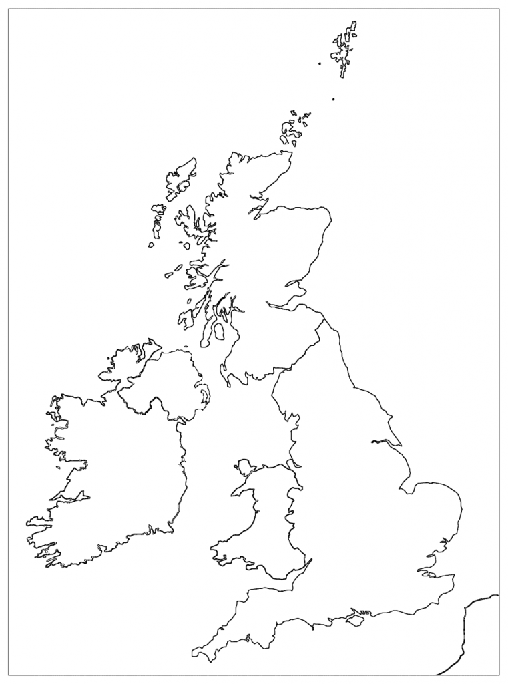

Suggested background research to read/watch/listen!
This is not compulsory, and you definitely do not have to read ALL of these texts! However, it may be a good idea to choose one or two of the suggestions that you like the look of and have a read! This will be helpful for your A-level studies.
Reading suggestions - Starting points and helpful books

Word on the Move – John McWhorter | 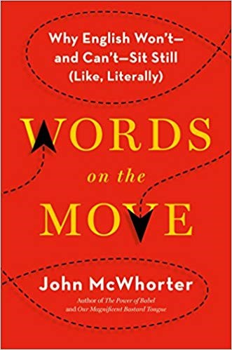 | The Life of Slang – Julie Coleman | 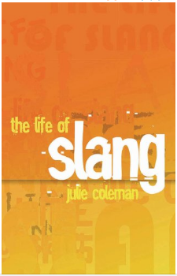
Language, Society and Power – Mooney and Evans | 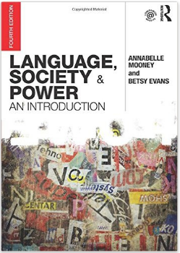 | Modern Tribes – Susie Dent | 
The Language Wars - Henry Hitchings | 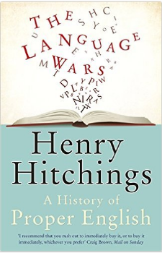 | You Are What You Speak –Lane Greene | 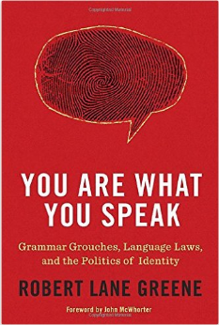
Talk on the Wild Side - Lane Greene | 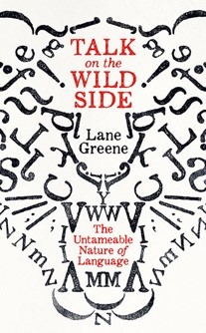 | OUP Revise AQA English Language | 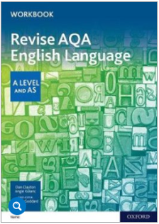
CUP A/AS Level English Language for AQA Student Book | 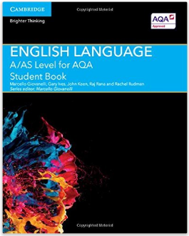 | EMC An Introduction to Language Frameworks – 2nd edition
OUP AQA A Level English Language: Student Book | 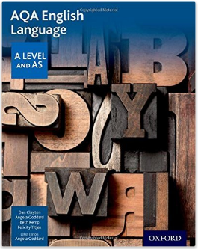 | Language Handbook (2nd edition): Key Thinkers on Key Topics | 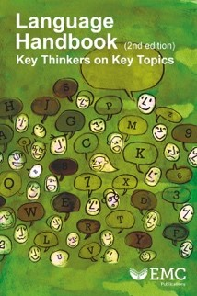
The Myth of Mars and Venus - Deborah Cameron | 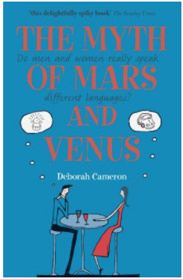 | Women, Men and Language (3rd edition) - Jennifer Coates | 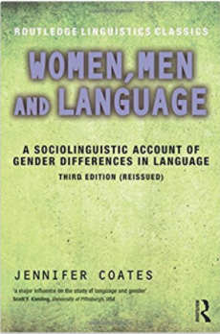
Women Talk More Than Men… and Other Myths About Language Explained - Abby Kaplan | 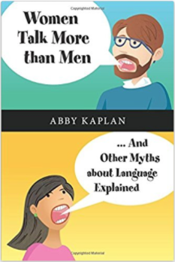 | Sexed Texts – Paul Baker | 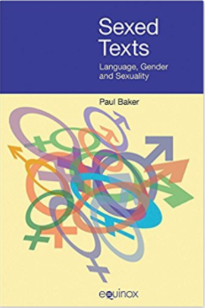
Child Language: acquisition and development – Matthew Saxton | 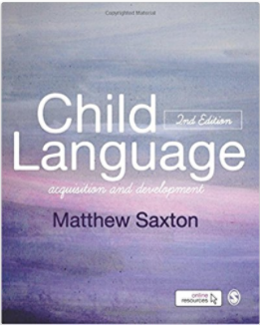 | Language and Power (3rd edition) – Norman Fairclough | 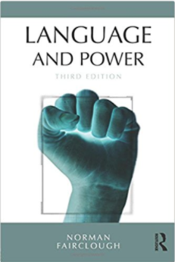
Language and Power: a resource book for students –Simpson and Mayr | 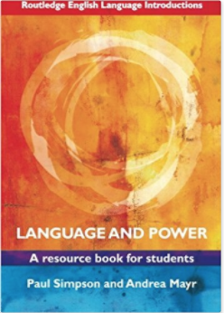 | Doing English Language – Angela Goddard | 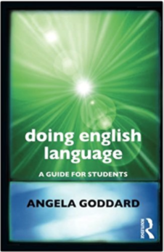
English in the World: History, Diversity, Change – Seargeant and Swann (eds) | 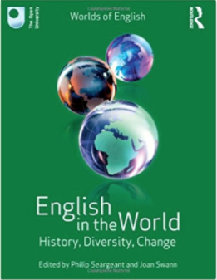 | Global Englishes: a resource book for students – Jennifer Jenkins | 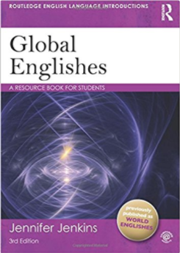

This whole series is also fab:
http://www.cambridge.org/gb/education/subject/english/english-language/cambridge-topics-english-language
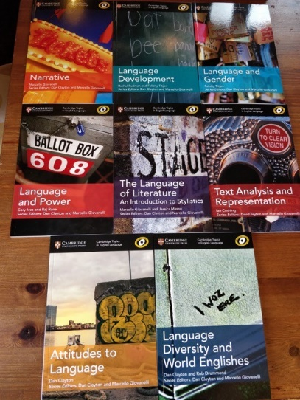

Watching suggestions
Here are some suggestions of lectures and talks to give you a taste of a few interesting topics in English Language.
• Watch a few minutes of these and choose a couple to watch all the way through. Don’t worry about making notes at this stage; just follow the line of argument and think about the ideas being offered.
• Once you have listened to a couple of lectures, try to jot down a few notes at the end. What were the key ideas? Did you understand the arguments being made? Were there any things you weren’t sure about and might need to look up?
• Many of the links from the TED talks offer suggestions for other language-based lectures. Follow a few of those links and keep a note of which of these you found interesting, and some key ideas from them. Many of these could come in useful later in the course.
Professor Tim Grant on Forensic Linguistics
https://www.englishandmedia.co.uk/video-clips/clip-listing/leaping-into-language-emagclips
Lera Boroditsky on the links between language and thought
https://www.ted.com/talks/lera_boroditsky_how_language_shapes_the_way_we_think
John McWhorter on digital language and texting
https://www.ted.com/talks/john_mcwhorter_txtng_is_killing_language_jk
Deb Roy on children’s language development
https://www.ted.com/talks/deb_roy_the_birth_of_a_word
Anne Curzan on what makes a word ‘real’
https://www.ted.com/talks/anne_curzan_what_makes_a_word_real
Erin McKean on making up new words
https://www.ted.com/talks/erin_mckean_go_ahead_make_up_new_words
Claire Bowern on where English comes from
https://www.ted.com/talks/claire_bowern_where_did_english_come_from
John McWhorter on made-up languages in sci-fi and fantasy
https://www.ted.com/talks/john_mcwhorter_are_elvish_klingon_dothraki_and_na_vi_real_languages
David Crystal interviewed by Cambridge University Press
https://www.youtube.com/watch?v=59GMlpAdVok
https://www.youtube.com/watch?v=v8joftTbIxM

Listening suggestions
In recent years, a number of linguists have been sharing their ideas and passions with the public through radio shows and podcasts. Take a look through the recommendations provided and try listening to one or two in more depth. Most radio programmes can be accessed directly via the links, and the podcasts can be played through the links or using an app like Spotify.
The BBC’s Word of Mouth, hosted by Michael Rosen, offers a large archive of past episodes, all available for download.
https://www.bbc.co.uk/programmes/b006qtnz/episodes/player
A Debate About American English https://www.bbc.co.uk/programmes/b08g5533
Will Emoji Be the Future of English? https://www.bbc.co.uk/programmes/b08ffvp6
The Language of Lying https://www.bbc.co.uk/programmes/m000dfpy
Black British Identity and Black-related Words https://www.bbc.co.uk/programmes/m0004l93
Solving Crime with Language https://www.bbc.co.uk/programmes/m00027n6
Language, Gender and Trans Identities https://www.bbc.co.uk/programmes/b09r4k4l
Lexicon Valley, presented by John McWhorter https://slate.com/podcasts/lexicon-valley
Women’s Language https://slate.com/podcasts/lexicon-valley/2020/03/vocal-frywomen-language
Like, Sort Of… https://slate.com/podcasts/lexicon-valley/2019/11/politeness-in-the-english-language
Language on the Internet https://slate.com/human-interest/2019/07/john-mcwhorter-and-gretchen-mcculloch-onbecause-internet.html
Accentricity https://www.accentricity-podcast.com/
Lexitecture http://www.lexitecture.com/
Lingthusiasm https://lingthusiasm.com/
Talk the Talk http://talkthetalkpodcast.com/

