
Classical Civilisation
A Level

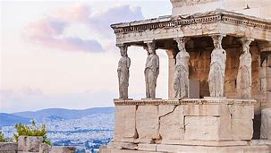
Summer bridging activities

Welcome to A Level Classics!
There is no time better than the present to begin immersing yourself in the art, literature, history and politics of people who lived over two thousand years ago.
You will be following the OCR course, and will be studying the following units:
Component | Brief description | Proportion of overall A level
The World of the  Hero. (H408/11) | An in‐depth study of Homer’s Odyssey and Virgil’s Aeneid. | 40%
Culture and the Arts: Imperial Image  (H408/22) | Study how Augustus Caesar was able to spin his public image to  convince all social classes of Rome that he was  their rightful leader. | 30%
Beliefs and Ideas:  Greek Religion. (H408/31) | Study why the Greeks thought of their gods as they did, and explore  Delphi, Olympia and Athens, learning about how Greeks worshipped. | 30%

We start the course in 1250BCE at the end of the ten year long Trojan War between the forces of Greece and the Trojans.

We are introduced to the world of epic poetry through Homer’s tale of the crafty Odysseus, King of the island of Ithica, who has fought at Troy and now seeks to return home. However, on the way he will face a long and difficult journey, facing storms, monsters, seductive temptations, battles and a struggle to reclaim his homeland. All set against a backdrop of the anger of vengeful gods…

The activities in this pack focus on introducing you to the world of these gods, so integral to everyday life in Ancient Greece, and you will explore the main gods’ powers, traits, and appearance. You will also explore the world of Homeric Greece and be introduced to the Odyssey poem.
Let us begin…

If you have any questions about the course, do not hesitate to ask
Andy.
andrew.leath@ccsw.ac.uk

First, we have to explore exactly what we mean by "Olympian gods." Mount Olympus is a real mountain in the north of Greece. Gradually, it became associated less and less with an actual mountain and more with an imaginary place high above the earth. According to the ancient Greeks, the gate to Olympus was made of clouds and it was guarded by four goddesses, the Seasons. Each god had his or her own dwelling place, but Olympus was home base.
There were up to 14 gods considered Olympian gods. Seven of them were Zeus and his siblings, and seven others were children of Zeus. Sometimes only 12 will be listed. The Greeks and Romans shared mythology, so you will find two names for most gods.
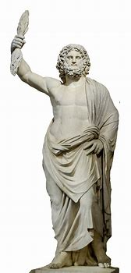
Zeus (Jupiter/Jove for the Romans) was the king of the gods. He was dominating, powerful and had a soft spot for pretty women. He could be terrifying when angry. His symbols were the thunderbolts, or lightning bolts made for him by the Cyclopes (his uncles); the eagle; and the sceptre, or rod.
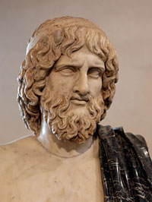
Hades, or Pluto, was the god of the underworld and of the dead. He was called the same names by the Romans, but they also sometimes called him Dis or Dis Pater. He was Zeus’s brother and married Persephone after kidnapping her against her will. He was gloomy and frightening.
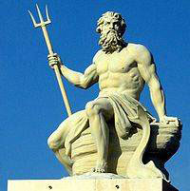
Next, we have Poseidon, or Neptune, as the Romans called him. He was Zeus’s brother, and he was the god of the sea and also earthquakes. He often is shown with a three-pronged spear called a trident that was made for him by his nephew, Hephaestus, and/or a fish.
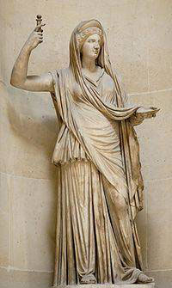
Our first goddess is Hera. She sits on the right side of Zeus and is his wife. Of course, she’s his sister, too, but that’s the way it was on Olympus. Hera’s Roman name is Juno, and she is the queen of the gods. She is the guardian of marriage and was well-loved by the Greeks; it’s ironic that she’s the goddess of marriage but her own marriage was so bad. She was often jealous of her husband’s affairs and could be cruel to his lovers, even the ones who didn’t want anything to do with him, but she could be tender and loving as well. The peacock was her symbol. In fact, the circles in a peacock’s tail are said to be the eyes of her 100-eyed servant, Argus.
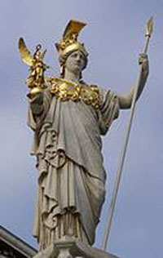
Next is Athena, or Minerva (Roman), the daughter who sprang fully formed from the head of Zeus after a major headache. She is the goddess of wisdom and war and also the protector and namesake of the city of Athens. She preferred reason to violence unless she was pushed. She turned Arachne into a spider for bragging that she could spin better than Athena. She was very competitive and is often pictured with her helmet and a spear. She carried Zeus’s shield, called the aegis. The owl was her bird.
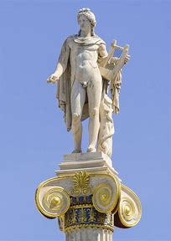
Apollo was a twin. His Roman name was the same as his Greek name. He was the god of the sun or light, poetry, music and medicine and was famous for his oracles (wise women to whom he gave his power to predict and interpret the future). He was very proud and also protective of his mother and sister. His symbols were the gold bow and arrows, and he often appears golden and shining. He wears a laurel wreath in memory of Daphne, who didn’t want to be his lover and prayed to Mother Earth for help escaping him; she was turned into a laurel tree.
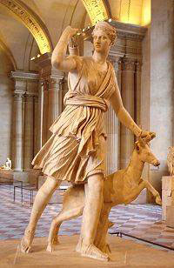
Artemis was Apollo’s twin. Her Roman name was Diana, and she was the goddess of hunting, chastity and the moon. She protects women and small children, is fiercely independent and particularly dislikes men. In pictures, she is seen accompanied by three hunting hounds, a bow and a fawn.
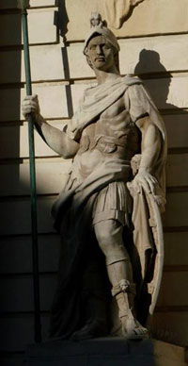
Ares or, as he is known by his Roman name, Mars, was the god of war. He would fight on both sides, if possible. He was young, strong and handsome, and liked to dress in battle clothes even when he wasn’t fighting.
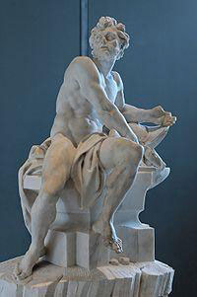
Hephaestus, or Vulcan, was born lame and was further crippled when he was thrown from Olympus by his mother, Hera, in a rage. He was the only Olympian with a disability. He was unhappily married to Aphrodite and worked as a blacksmith in the gods’ forge.
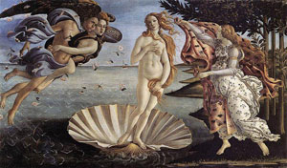
Hephaestus’s wife, Aphrodite, whose Roman name was Venus, was the goddess of love and beauty. She was born out of sea foam when the blood of Uranus dropped into the ocean. She was the mother of Eros and was irresistibly charming, fickle, vain and competitive. Her symbol was a cestus, or magic belt, that made everyone fall in love with the wearer; sometimes she would lend it to humans. This is a famous painting of the birth of Venus, or Aphrodite, by Botticelli.

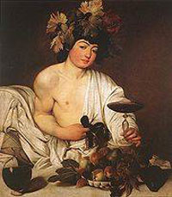
Dionysus was the partier of the mountain retreat. He was Zeus’s son by another woman, who was driven crazy by Hera and her jealousy. Dionysus went all around teaching people how to make wine and having a good time. Eventually, Hestia gave up her throne for him, and he lived on Olympus. He was the god of wine, of course, and also vegetation.
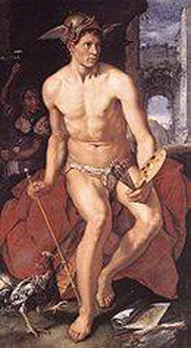
Hermes, or Mercury, was the god of science and invention, but he is best known as the messenger of the gods. He is often pictured with a winged helmet and sandals. He is said to have invented the alphabet, boxing and gymnastics! In this painting by Goltzius, you can see his helmet with wings; he’s not wearing his famous sandals, though.
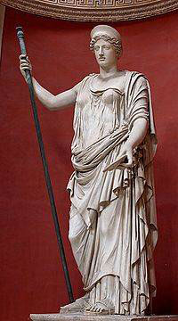
Demeter was the goddess of the crops and the harvest. She is also known as Ceres (Roman) and sometimes Deo. Her symbols include a torch, a crown, a sceptre and stalks of grain. She is often portrayed with her daughter, Persephone, who was kidnapped by Hades and taken to the underworld. By the time she was rescued, she’d eaten six pomegranate seeds, so she couldn’t escape the underworld entirely. Her mother was so frantic that winter draped the land, and no crops would grow. A deal was struck, and Persephone was allowed to return to her mother for half of the year. So, each year, when she returns to the underworld, autumn comes, then winter — but when she returns to her mother, spring and summer come again.
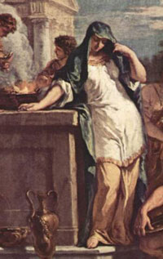
Hestia was Zeus’s sister and the goddess and protectress of hearth and home. She is also known by her Roman name, Vesta. She was gentle and kind and was very popular with the Greeks. She didn’t have a lot of adventures, so she’s rarely pictured in art.

You now will have a basic idea of who the gods of Ancient Greece were. Over the following pages there will be tasks to complete ready for when you start in September. These will help prepare you for independent research, notetaking and exploring the exam specification and the transition from GCSE to A Level.

Task 1

Olympians quiz
Time to test yourself — and beware, answers may be used more than once!
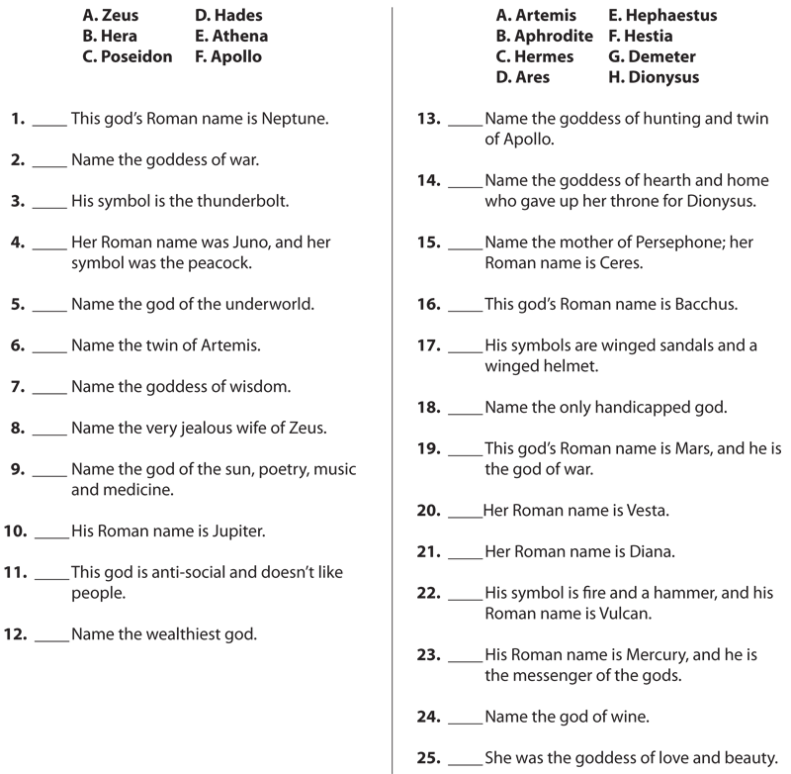

Task 2
The Open University – Courses
In September, you will start with The Odyssey. Please complete this Open University course, using the link below, and bring me a copy of your statement of participation:
The Odyssey
Exploring Homer’s Odyssey | OpenLearn - Open University
Task 3
Use the link below or search for the BBC podcast ‘In our time-the Odyssey’. As you listen to the 30min discussion use the questions below to help you think about why this epic poem is important and why it is the first thing we study on the Classical Civilisation A level!
In Our Time - The Odyssey - BBC Sounds
- What are some of first things you learn happen to Odysseus on his journey?
- Who are some of the principal characters? What do they do?
- What is happening at home in Ithaca?
- Who are the leaders of the suitors and who remains loyal?
- Why is Telemachus interesting as a figure?
- Why does Ithaca show us? Why does this contrast to Odysseus’ journey?
- Who is Athene and what is her role in this story?
- What is an epithet? What types is Odysseus given and why? (think about his cunning and examples of this).
- Why is Odysseus’ behavior different to what would be expected of a hero when he returns to Ithaca?
- Why is the structure of the poem so different? Why might this be effective?
- What is the debate around the author of the Odyssey?
- How would the Odyssey have been delivered to a Greek audience?
- Why could it be said Odysseus is a very interesting character, perhaps compared to Achilles?
- Why is homecoming such an important theme in the Odyssey?
- What is the impression of women given in the poem?

Task 4: Greek Epic - The Odyssey: Read the episode below and explain how the poet has made the scene dramatically effective:
Pallas Athene had fuddled the suitors’ wits to such effect that they greeted Telemachus’ reply with peal after peal of uncontrollable laughter. But before long their laughing faces took on a strained and alien look. Blood was spattered on the food they ate. Their eyes were filled with tears, their hearts with forebodings of grief. And now the voice of the godlike prophet Theoclymenus was heard. “Unhappy men”, he cried, “what horror is this that has descended on you? Your heads your faces and your knees are veiled in night. […] The walls and lovely alcoves are splashed with blood. The porch is filled with ghosts. So is the court – ghosts hurrying down to darkness and to the Underworld. The sun is blotted out from heaven and a foul mist has crept upon the world.” They laughed at him.
Task 5
Using exam board materials
https://www.ocr.org.uk/qualifications/as-and-a-level/classical-civilisation-h008-h408-from-2017/
A useful resource for your A level study is provided by the examination board. Spend some time exploring this website. You will find information about the course, exam papers, mark schemes and exam reports. Download the specification which has valuable details on all units of study. Practice is a key part of success at A level, so make sure you are familiar with the types of question that can be asked.
Set texts and preparation
Make sure you have your own copy of the following poem ready for September. Feel free to get reading-you will need to know this inside out eventually!
It is also important to get the below translation-this is the same as OCR, the exam board, will use.
Homer, ‘Odyssey’ translated by E. V. Rieu, revised translation by D. C. H. Rieu (Penguin)
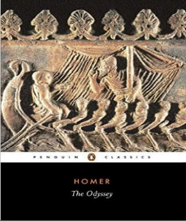

Get yourself some ring binder folders, topic dividers and plastic wallets – these will be essential to organise your work.


Optional activities:
The Open University is running a free introductory course on the Classical World. This course will be very useful if you have not studied Classics at GCSE.
Introducing the Classical world | OpenLearn - Open University

Academic Reading
Beard, M. (2016) SPQR: A History of Ancient Rome, Profile Books
Fry, S (2017) Mythos, Penguin
Fry, S. (2018) Heroes, Penguin

Documentaries
Prof Mary Beard – Ultimate Rome
Episode 1 - https://www.youtube.com/watch?v=LL_acQHNs-o
Episode 2 - https://www.youtube.com/watch?v=urJbBsdvjKU
Episode 3 - https://www.youtube.com/watch?v=5alrhQKGOjg
Episode 4 - https://www.youtube.com/watch?v=ZvBghnYyiR4
Prof Mary Beard – Meet the Romans
Episode 1 - https://www.youtube.com/watch?v=rggk_H3jEgw
Episode 2 - https://www.youtube.com/watch?v=9JFw8M4PBUI
Prof Michel Scott – Delphi https://www.youtube.com/watch?v=wBnOs8GmYHk
Prof Andrew Wallace-Hadrill – Ancient Cities
Athens - https://www.youtube.com/watch?v=SNqOOOiGgcY
Rome - https://www.youtube.com/watch?v=hdYRgjLurTs

