A-Level Business Bridging Activities
Task 1 - The Entrepreneur Research Project (1.5 Hours)
Link to specification - As part of the first topic you will cover when you join the course, you must develop an understanding of the reasons for setting up a business (financial & non-financial), and the characteristics and risks of being an entrepreneur.

Pick one entrepreneur who inspires you. This could be a global figure (e.g., Steven Bartlett, Oprah Winfrey, etc.) or a local independent business owner. Research their journey and create a poster covering the following areas:
- What was their original business idea, and what gap in the market did they spot?
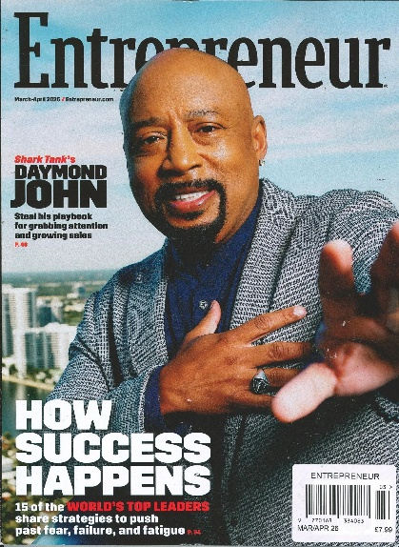
- Did they start their business primarily for financial rewards (profit, wealth), or non-financial reasons (independence, ethical mission, turning a hobby into a job)? Explain your reasoning.
- Identify three key characteristics they possess (e.g., resilience, creativity, risk-tolerance) and provide a specific example of how they demonstrated each one.
- What was the biggest risk or challenge they faced when starting up, and how did they overcome it?

Where can I source my information?
- Reputable Articles
- Company Website (e.g. ‘Company Story’ page)
- Podcasts (e.g. The Diary of a CEO)
- Autobiographies

Assessment Skill Built – Application (AO2). Your assessments will test your ability to use real business examples to back up your points, rather than just writing about theory in the abstract.

Task 2 – The Importance of a Business Plan (1 Hour)
Link to specification - Within the first unit, you must be able to understand the purpose and value of a business plan; taking into consideration objectives, risk, rewards, costs, and resources.


Imagine you are an investor on Dragons' Den. A new entrepreneur has come to you looking for a £50,000 investment, but they haven't written a business plan because they claim, "The market changes too fast, so planning is a waste of time."
Task on the reverse!

Write a short persuasive pitch (approx. 250–300 words) to this entrepreneur explaining why a business plan is vital before you will even consider investing. You must include:
- How a plan helps them manage resources and costs.
- What tends to be included within a business plan and why
- Why it is valuable for identifying potential risks before they happen.

Task 3 – Understanding Competition (1 hour)
Link to specification - You must also be able to show an understanding of the meaning and importance of competitiveness.

"Competitiveness" is a business's ability to pull customers away from its rivals. Choose two rival brands that operate in the same market (e.g., Apple vs. Samsung, Nike vs. Adidas, or Greggs vs. Subway).
Write a breakdown of how they each compete. This should cover the following areas:
- What is their competitive edge? Why do customers shop at the brand? What makes them unique to the other brand?
- How does their performance compare? Which has the greatest market share, number of sales, amount of profit, etc.?
- Why does this matter? Explain what would happen to one of these businesses if it stopped innovating or lost its competitive advantage.

Task 4 - The Ethical Dilemma (45 Minutes)
Link to specification – You must explore ethical dilemmas businesses face in decision-making.

Read the following mini-case study and complete the task below.
Scenario: A fast-fashion clothing retailer is planning to launch a new summer line. They have two manufacturing options:

- Option A - Use a supplier overseas that keeps costs incredibly low, allowing the business to maximise its profits and sell cheap clothes to consumers. However, working conditions at this factory are notoriously poor, and workers are paid below a living wage.
- Option B - Use an ethical, sustainable supplier that guarantees fair trade wages and organic materials. However, this will double the production costs, meaning the business will have to charge high prices and face much lower profit margins.
Write two paragraphs arguing which option the business should choose. You must explain the trade-off involved (e.g., if they choose ethics, what do they sacrifice? If they choose profit, what are the long-term risks to their reputation?).

