**A LEVEL PSYCHOLOGY - SUMMER ASSIGNMENT**

[](http://www.google.co.uk/url?sa=i&rct=j&q=&esrc=s&source=images&cd=&cad=rja&uact=8&ved=0ahUKEwie8ujd3-DUAhXCshQKHXOiC4sQjRwIBw&url=http://weknownyourdreamz.com/symbols/clinical-psychology-symbol.html&psig=AFQjCNEcxorp0Y9MgGXGO08mBWHwBb7EUg&ust=1498746421776674)

**Name_____________________________________________**

* **Complete the work in the booklet.**
* **You should bring this to your first psychology lesson.**
* You will also be having a maths test at the beginning of the course. You should prepare for this test by revising your GCSE maths content – percentages, fractions, decimals, averages and graphs.

Use the following websites to help you:

<http://www.simplypsychology.org/simplypsychology-index.html>

[Psychology | tutor2u](https://www.tutor2u.net/psychology)

**What is psychology?** Psychology is the scientific study of the mind and behaviour. It’s all about understanding how we think, feel, and act, both as individuals and in groups. As an A-level student, you’ll explore a range of topics, from how our brains process information to how we develop throughout our lives, how we interact with others, and even why we sometimes behave in ways we don’t expect.

**Biopsychology**

**Label the diagrams below:**

1. **Motor Neuron 2) Complete the table below**

|  |  |  |
| --- | --- | --- |
|  | **Structure** | **Function** |
| **Motor neuron** |  |  |
| **Sensory neuron** |  |  |
| **Relay neuron** |  |  |

**3) Label the synapse**

**4) The endocrine system is a collection of glands and organs that produce and release hormones into the bloodstream. These hormones help regulate many vital functions in the body, such as metabolism, growth and development, mood, and sexual function.**

**Pick two glands and hormones of the endocrine system and explain their function:**

**Gland 1:**

**Gland 2:**

**Key studies in Psychology:**

**Find out about the details of the following studies in psychology and summarise them below, using specialist terminology:**

**Behaviourism:**

1. **Pavlov’s Dogs**

**On the diagram add the Neutral stimulus (NS), Unconditioned stimulus (UCS), Unconditioned response (UCR), Conditioned stimulus (CS) and Conditioned response (CR)**

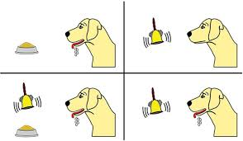

1. **Skinner’s Rats**

**Include a definition of positive reinforcement and negative reinforcement.**

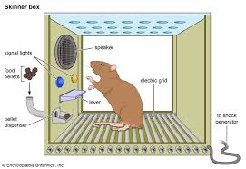

**Social learning theory:**

1. **Bandura’s Bobo doll**

**Include a psychological definition of the term modelling.**

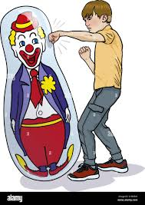

**Cognitive approach:**

1. **Complete this diagram of the Multistore Model of Memory.**

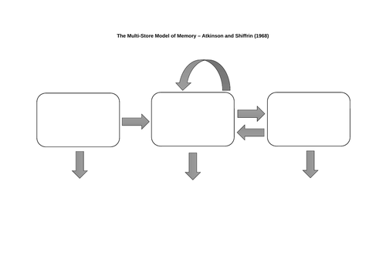

|  |  |  |  |
| --- | --- | --- | --- |
|  | Sensory register | Short term memory | Long term memory |
| Capacity |  |  |  |
| Duration |  |  |  |
| Coding |  |  |  |

**Humanistic approach:**

1. **Complete the diagram of Maslow’s hierarchy of needs.**

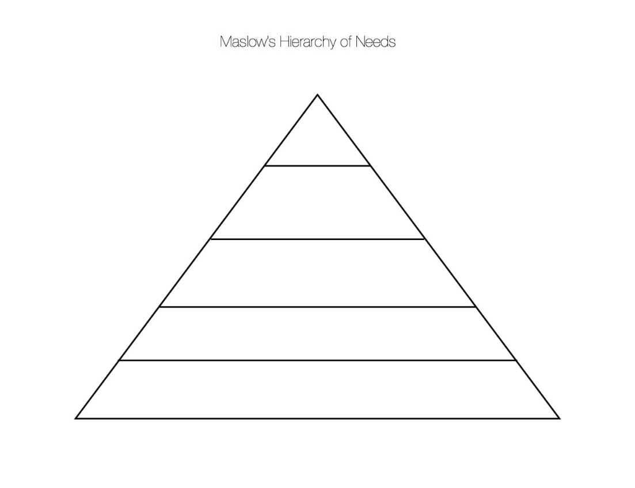

**Psychodynamic approach:**

1. **Write two sentences about the structure of personality: the Id, ego and superego.**

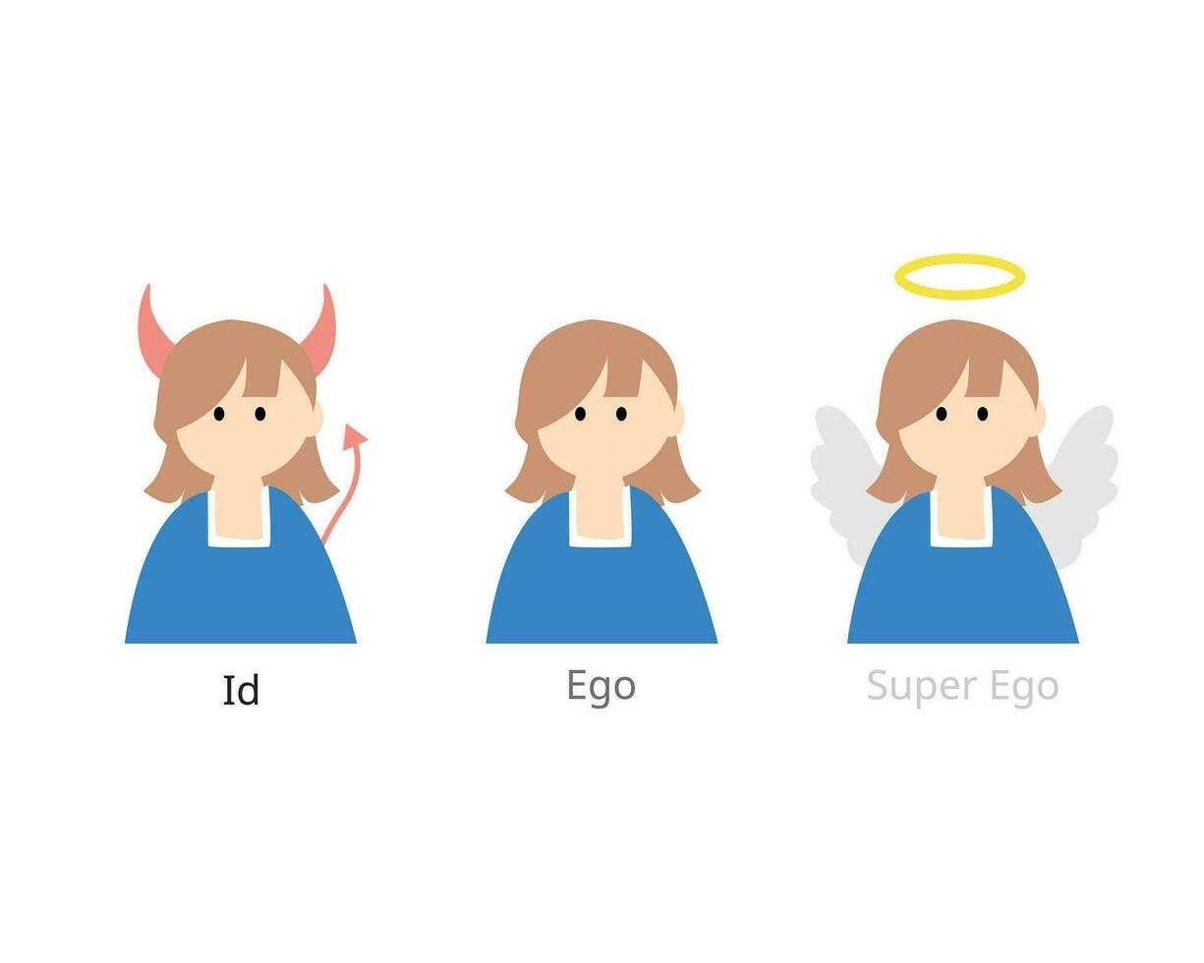

**Biological approach:**

1. **What does the data in the graph below tell us about the nature of schizophrenia?**

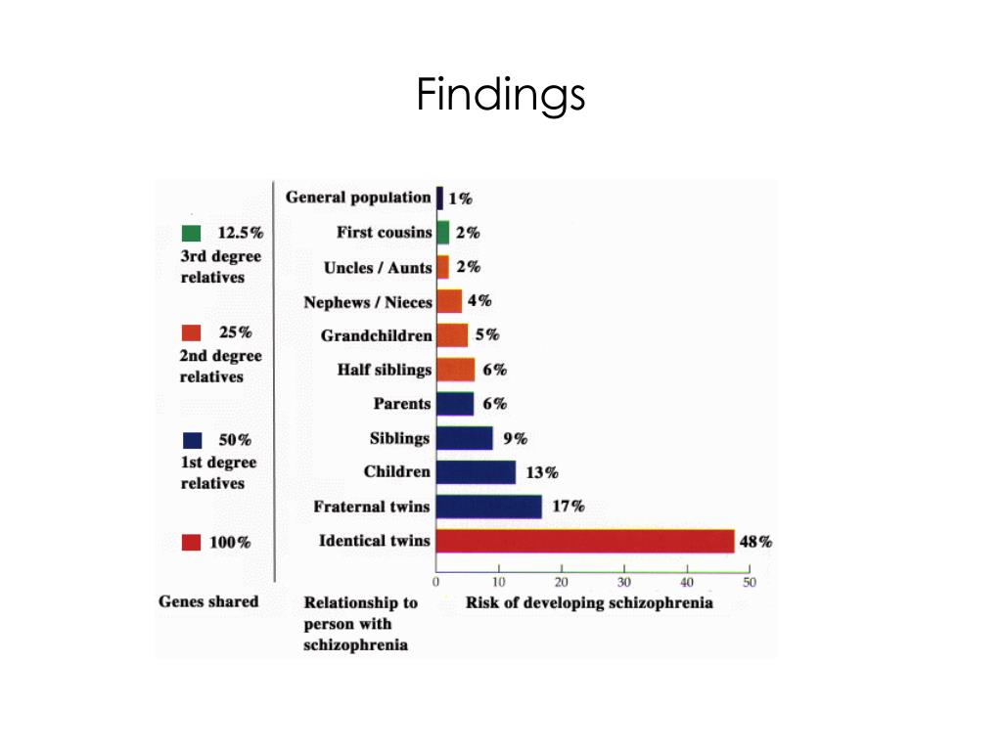

**Research methods**

**Task: Find out about the types of experiment and complete the table below: Complete a brief description of each type of experiment with reference to the IV and DV. Give two strengths and two limitations of each.**

|  |  |  |  |
| --- | --- | --- | --- |
| **Type** | **Description** | **Strengths** | **Limitations** |
| **Laboratory experiment** |  |  |  |
| **Field experiment** |  |  |  |
| **Quasi experiment** |  |  |  |
| **Natural experiment** |  |  |  |

**Maths: Complete the following maths problems**

**Decimal places:**

Round to 1 decimal place

a) 0.374

b) 0.798

Round to 2 decimal places

a) 0.136

b) 0.138

**Ratios Simplify**

a) 5 : 10

b) 15 : 5

c) 5 : 50

d) 52 : 56

**Significant figures:**

Round to 1 significant figure

a) 15

b) 983

Round to 2 significant figures a) 0.133

b) 0.0403

c) Find the mode of the data given below.

8 6 5 3 3 6

mode =

**Measures of Central tendency**:

1. Find the mean of the data given below.

6 6 1 2 1 8

mean =

1. Find the median of the data given below.

15 20 10 15 14 23 14

median =