



Name:

An introduction to UK politics

A Level Politics Bridging Activities

Welcome to A Level Politics!

We start the course by looking at how people participate in democracy in the UK and the numerous ways that people can get involved in the political process. First year is mainly spent studying politics in the UK. We look at the political parties and our rights as well as the roles of the Prime Minister and Parliament.

Over the course of the two years we will go on to study politics in the USA and political ideas. Viewed as a whole, the course offers you a comprehensive package of political knowledge.

The tasks in this bridging activities pack will give you the opportunity to take your first step into politics in the UK. You can identify some of the movers and shakers of the last few decades, keep up to date with politics on social media and look back at how the political system has developed in the UK.

Overall, studying politics at A Level is a deeply rewarding, challenging and immersive experience. You will have your chance to shape your views on the world around you on a whole host of topics and learn how you are part of the political process and not just a casual observer!

So, let us begin…

If you have any questions about the course, do not hesitate to ask me at:

[ben.connor@ccsw.ac..uk](mailto:ben.connor@ccsw.ac..uk)

**Task One – Who’s who in British Politics?**

Look at the below photos of British politicians. Can you identify them? Which party do/did they represent? Which offices have they held (Prime Minister? Leader of the Opposition?). Get your family involved and see if you can name them all.

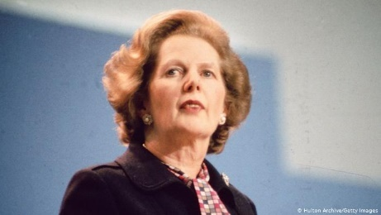

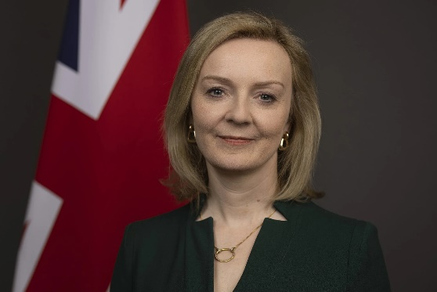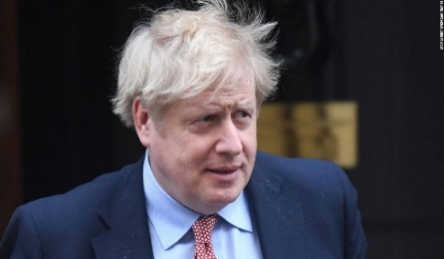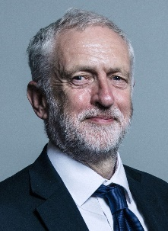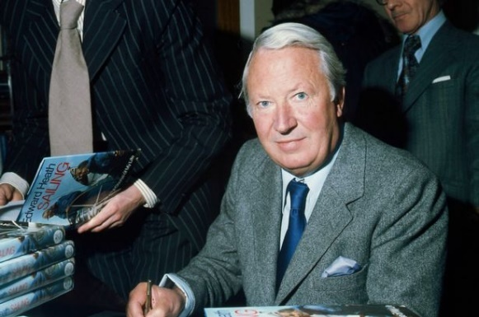

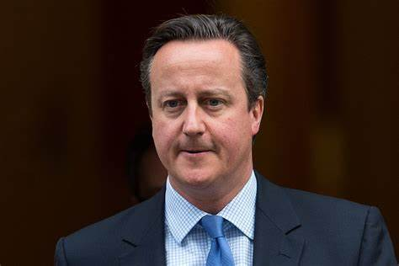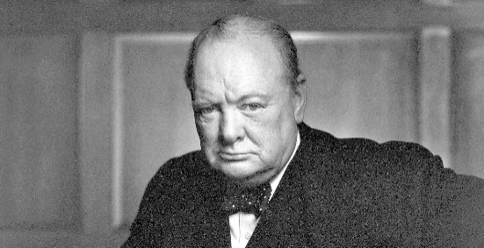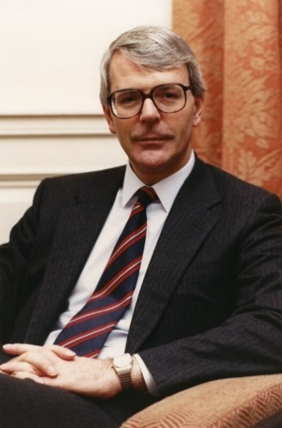

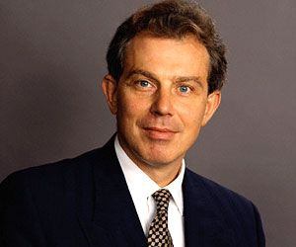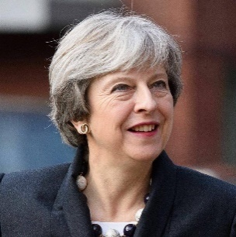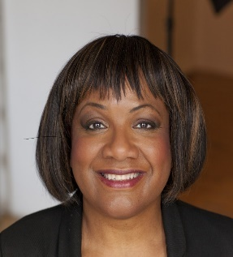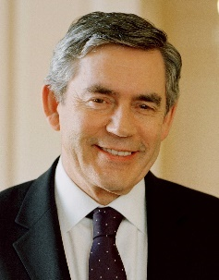

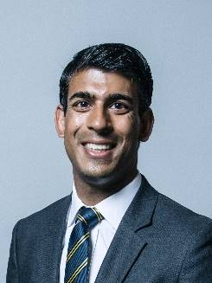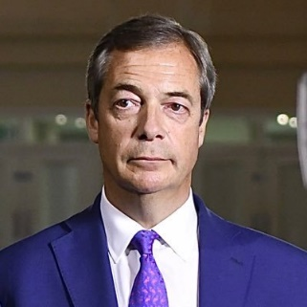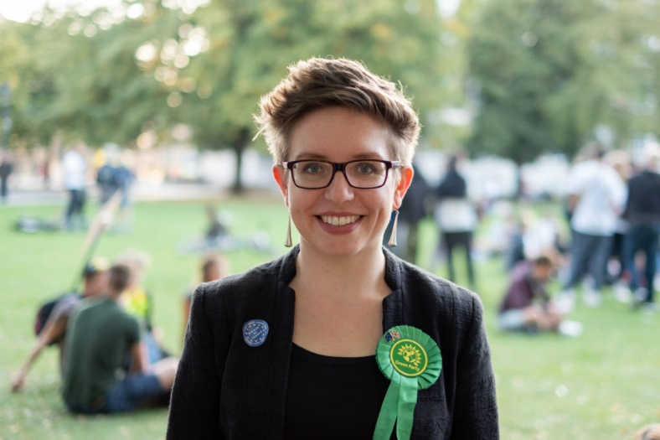

**Task Two – News and Politics**

Politics is a subject which cannot be unplugged from news and current affairs. X and other platforms are used by journalists and politicians alike to share news and information as well as discuss political issues. You could **create yourself an X (Or another platform) account** and follow the below for political information and news:

**@Britainelects (for news and updates on all things elections in the UK)**

**@BBCNews / @SkyNews (or any other news station of your choice – or even better, more than one!)**

**@bbcquestiontime (the UK’s most-watched political talk-show: BBC Question Time)**

**@10DowningStreet (Prime Minister)**

**@POTUS (the president of the United States of America)**

**And a range of political journalists like Julia Hartley-Brewer, Owen Jones, etc…**

Your second task is to **keep an eye on these accounts** (as well as wider sources – the news and shows on TV, newspapers and others) over the summer and make a note of any particularly interesting news that is relevant to politics in the UK. You may even find some stories which are interesting internationally too.





**Task Three – UK Political History**

Create a **timeline** showing the major events in UK political history. On your timeline you should include a number of features such as:

* The signing of the Magna Carta
* The opening of the House of Commons
* The introduction of the Bill of Rights
* The Act of Union
* The creation of the three major political parties
* Representation of the People Acts
* European Communities Act
* The EU referendum

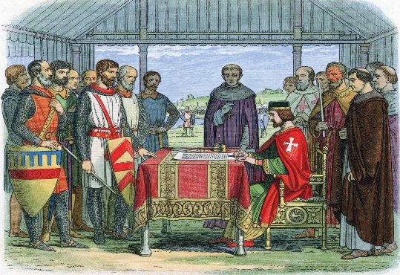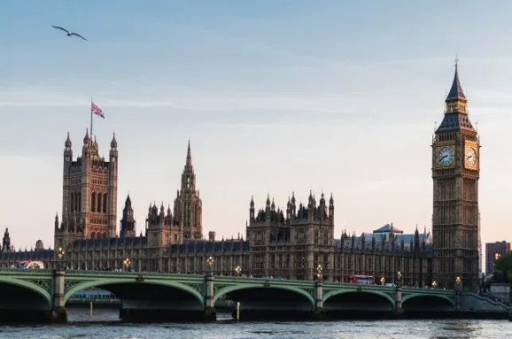

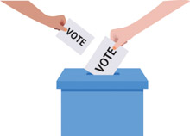

You can use the above list as a starting point and add in any other key events that you think influenced UK Politics – Add some information about the event and what impact it had, you could add pictures to help your remember too! You can use the template on the following page or organise your own from scratch

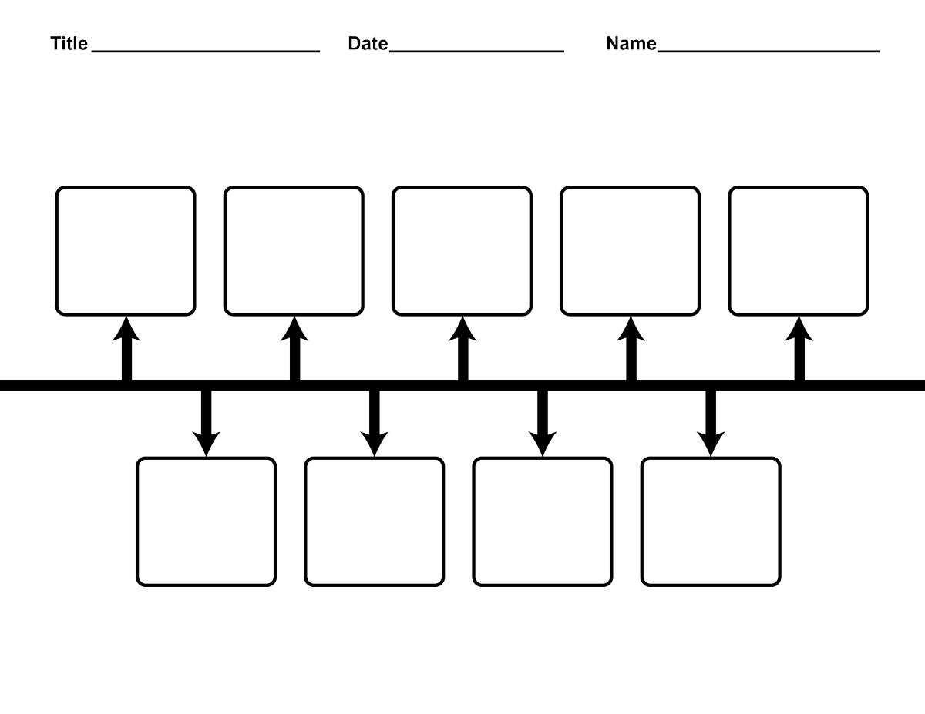

**Task Four – 2024 General Election Manifesto Task**

Using the links to the manifesto key policies below, choose a few policies and explain below why you support OR do not support that policy.

[Labour manifesto 2024: 12 key policies analysed - BBC News](https://www.bbc.co.uk/news/articles/cyxx1lq50nlo)

[Conservative manifesto 2024: 12 key policies analysed - BBC News](https://www.bbc.co.uk/news/articles/crgglmwwlggo)

[Lib Dem manifesto: 11 key policies explained - BBC News](https://www.bbc.co.uk/news/articles/cqeevzldj0jo)

[SNP manifesto: 11 key policies analysed - BBC News](https://www.bbc.co.uk/news/articles/c3ggl375nn7o)

[Reform UK manifesto 2024: 11 key policies analysed - BBC News](https://www.bbc.co.uk/news/articles/cqll1edxgw4o)

[Plaid Cymru manifesto: 11 key policies analysed - BBC News](https://www.bbc.co.uk/news/articles/crgg1z4n2vno)

[Green Party manifesto 2024: Key policies analysed - BBC News](https://www.bbc.co.uk/news/articles/czddq40z2zno)

Party: __________________________

Manifesto policy 1: ____________________________________________________________________________________________________________________________________________________________________________________________________________________________________________________________________________________________________________

Agree/disagree & why:

_____________________________________________________________________________________________________________________________________________________________________________________________________________________________________________________________________________________________________________________________________________________________________________________________________________________________________________________________________________________________________________________________________________

Party: __________________________

Manifesto policy 2: ____________________________________________________________________________________________________________________________________________________________________________________________________________________________________________________________________________________________________________

Agree/disagree & why:

_____________________________________________________________________________________________________________________________________________________________________________________________________________________________________________________________________________________________________________________________________________________________________________________________________________________________________________________________________________________________________________________________________________

Party: __________________________

Manifesto policy 3: ____________________________________________________________________________________________________________________________________________________________________________________________________________________________________________________________________________________________________________

Agree/disagree & why:

_____________________________________________________________________________________________________________________________________________________________________________________________________________________________________________________________________________________________________________________________________________________________________________________________________________________________________________________________________________________________________________________________________________