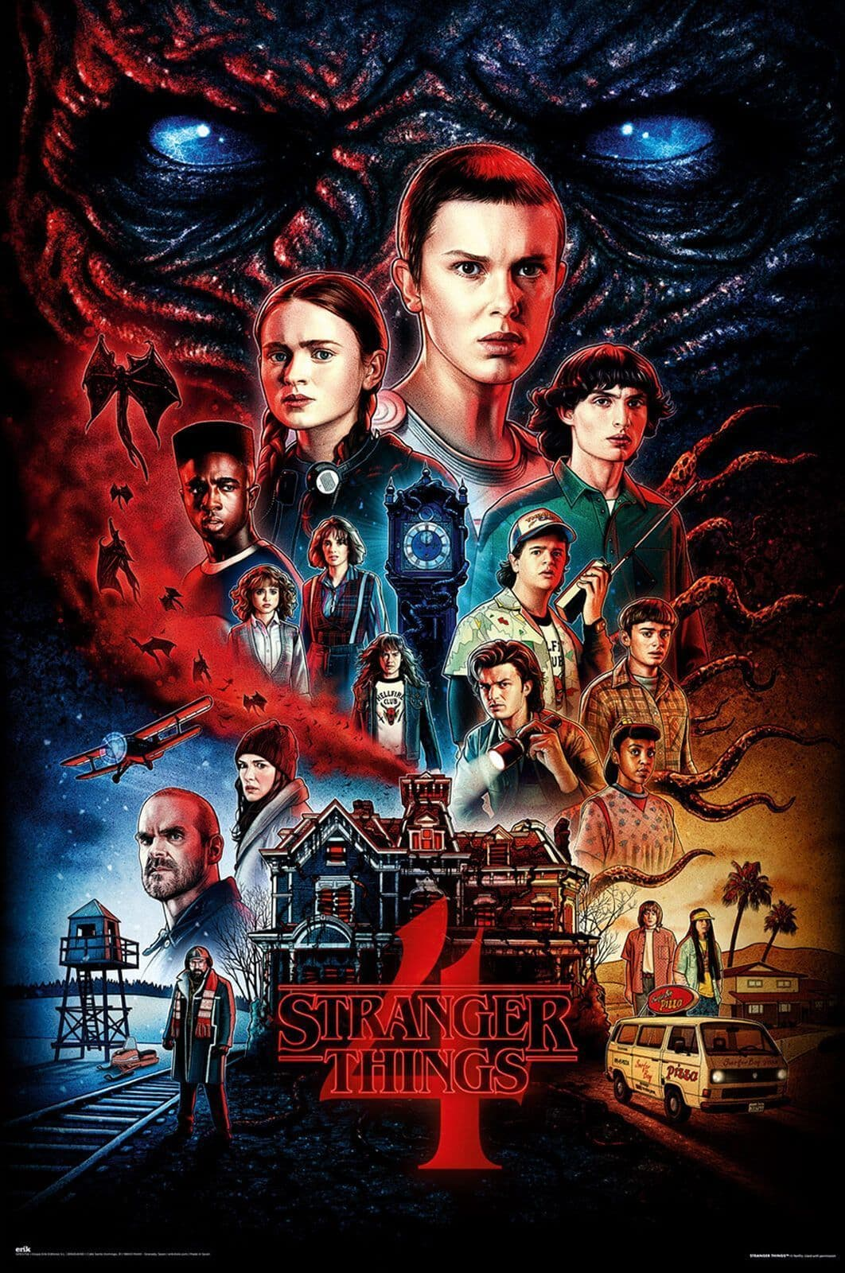

**Poster Analysis Task**

Use a poster of your own choice and analyse for the following areas:

* What meanings does the poster generate? (Evil is significant as shown by the red creature).
* What elements of mise-en-scene can be shown? (Settings, props, costumes, lighting, actors).
* How are stereotypes represented? For example, genre aspects (bats for horror in above poster).