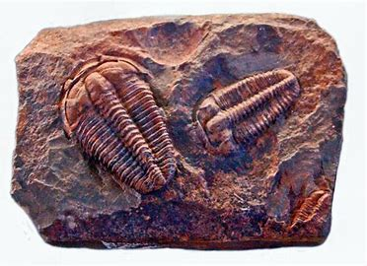**CHESHIRE COLLEGE SOUTH AND WEST**

**GEOLOGY A-LEVEL BRIDGING WORK**

**A-LEVEL TOPICS STUDIED – EDUQAS**

**A1 Rocks and minerals, Geological time and Principles, Earth Structure, Plate tectonics, Past Lives, geological mapwork .**

**A2 Geohazards, Igneous, Sedimentary, Metamorphic Rocks, Rock Deformation, Mapwork, Past Lives and Climates, Earth Materials and Natural Resources, Quaternary Geology.**

**Task 1**

**The Rock Cycle**

You should have learned about the rock cycle in Science; this concept is key when studying Geology and, in preparation for our first topic on rocks and minerals, a good understanding of this is essential. For this task I would like you to:

1. Draw a detailed diagram of the rock cycle. You should research this using the internet and books if you have access to them, as well as the Geological Society factsheet found here. [ks2-rock-cycle-factsheet.pdf](https://www.geolsoc.org.uk/media/lgmn5rys/ks2-rock-cycle-factsheet.pdf)
2. Use the information on the Geological Society factsheet to add detailed annotations and definitions to each stage of your rock cycle.

3. If there are any words you don’t know, research their definitions and make a glossary to bring with you in September

**Task 2**

1. How is geological time divided? Research the stratigraphic column and devise a pneumonic to remember the order of the division of time.

[Geological timechart - British Geological Survey (bgs.ac.uk)](https://www.bgs.ac.uk/discovering-geology/fossils-and-geological-time/geological-timechart/)

**Task 3**

1. What is the Anthropocene? What is the geological evidence for the Anthropocene?

**Please bring all work with you to your first lesson in September.**