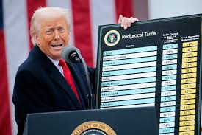**Donald Trump and his Trade War**

DonaldTrump was inaugurated as the 47th President of the United States on the 20 January 2025. He promised to deliver the ‘most extraordinary first 100 days of any presidency in American history’. And to date he certainly has by initiating a trade war initially with Canada, China and Mexico ….. and then the rest of the world!!!!!

When President Donald Trump unveiled sweeping taxes on imports from around the world last month, he said the measures aimed to right America's trade relationships.

This has subsequently led to tit for tat retaliations from many countries and unrest in many industries. For example Jaguar Land Rover stopped exporting cars into the USA because of the high tariffs and if recent news headlines are correct they were literally hours away from making hundreds of workers (with highly specialised skills) redundant until the 11th hour reprieve.

**US and UK agree deal slashing Trump tariffs on cars and metals**

The US has agreed to reduce import taxes on a set number of British cars and allow some steel and aluminium into the country tariff-free, as part of a new agreement between the US and UK.

Trump has said repeatedly that he wants to tax imports of pharmaceuticals, in a bid to ensure the US has a strong manufacturing base for critical medicines.

The UK said the US had agreed to give British firms "preferential treatment".

But it will leave a 10% duty in place on most goods from the UK.

"One thing is clear, Trump's trade tariffs are still hitting key British industries, threatening the livelihoods of people across the UK." Consider his most recent threat of 100% tariffs on films made outside of the USA!!!

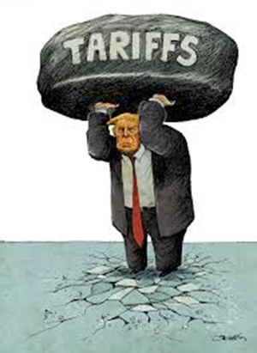You have been asked to investigate:

1. Globalisation: what factors have driven globalisation and what benefits and drawbacks does it bring to consumers in both product and labour markets?
2. What is the difference between a trading bloc and a customs union?
3. David Ricardo was a British political economist, politician, and member of Parliament. He is recognized as one of the most influential classical economists, alongside figures such as Thomas Malthus, Adam Smith and James Mill. Ricardo introduced the concept of "comparative advantage", suggesting that nations should concentrate resources only in industries where they have the greatest efficiency of production relative to their own alternative uses of resources. YOU have been asked to investigate both comparative and absolute advantage In relation to international trade and globalisation.
4. Tariffs and quotas are protectionist policies that arise on paper 2 regularly. YOU have been asked to illustrate the impact of a tariff and quota on a particular product or market and analyse the impact on both producer and consumer surplus.

OTHER recent headlines**: UK takes control of British Steel under emergency powers**

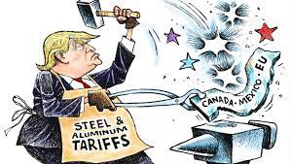The UK government is taking control of Chinese-owned British Steel after emergency legislation was rushed through Parliament in a single day. Business Secretary Jonathan Reynolds told MPs the government's likely next step would be to nationalise the Scunthorpe plant, which employs 2,700 people. But he said he was forced to seek emergency powers to prevent owners Jingye shutting down its two blast furnaces, which would have ended primary steel production in the UK. MPs and peers were called back from their Easter holidays to debate the legislation in an extremely rare Saturday sitting of both houses of Parliament.It has now received Royal Assent after being passed by the Commons and Lords.

The UK steel industry was privatised in 1988 by the Conservative party. Prior to this it has been a nationalised industry since 1967. Many believe the steel industry to be strategically important to the country. What do you understand by this? How might the Trump reversal on ‘some’ aluminium and steel and the commitment of the UK government to Heathrow’s third runway and its priority to build lots of affordable homes help this market?

