**A Level Drama and Theatre- Voices from Across Shutdown**

*“The spiralling coronavirus pandemic forced all UK theatres to shut down. Curtains fell across the country. Stages plunged into darkness. The work of months or years disappeared in an instant. Stories honed by the collaborative talent of thousands of theatre artists were snuffed out. With theatres gone, the tacit assumptions underlying our motto were exposed: a story was no longer enough without the infrastructure to share and sustain it. On 17 March 2020, just twelve hours after the theatres closed, Papatango’s launched ‘Isolated But Open: Voices from Across The S h u t d o w n ’ , t o c re a t e a n e w infrastructure that would ensure stories could continue to be told.” Chris Foxon*

**Task 1:** Performers and writers from across the country submitted original monologues to Papatango based on experiences in lockdown. Out of 2,063 entries they selected a total of 12 to be published. Read a selection of the speeches here: <https://www.nickhernbooks.co.uk/plays-to-perform/asset/7939?cmsAsset=1>

**Task 2:** Each of the 12 winning monologues were performed and filmed by professional actors. Watch a few of your favourites: <https://papatango.co.uk/isolated-but-open/>

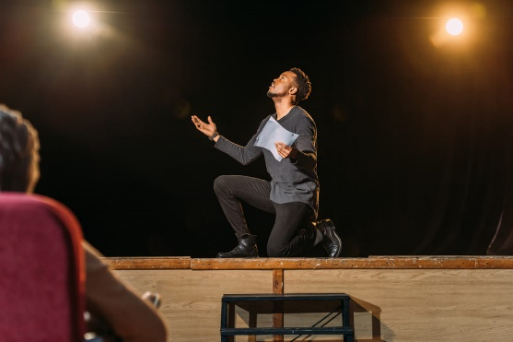

**Task 3:** Using the theme ‘Voices from Across Shutdown’, write your own original monologue

**Extension task:** Rehearse and perform your monologue. After all, monologues were written for the stage, not the page.