The Gods of Olympus

Classics A Level Bridging Activities

Welcome to A Level Classics!

We start the course in 1250BCE at the end of the ten year long Trojan War between the forces of Greece and the Trojans.

We are introduced to the world of epic poetry through Homer’s tale of the crafty Odysseus, King of the island of Ithica, who has fought at Troy and now seeks to return home. However, on the way he will face a long and difficult journey, facing storms, monsters, seductive temptations, battles and a struggle to reclaim his homeland. All set against a backdrop of the anger of vengeful gods…

The activities in this pack focus on introducing you to the world of these gods, so integral to everyday life in Ancient Greece, and you will explore the main gods’ powers, traits, and appearance. You will also explore some literary sources to help explore the thoughts of the time.

Let us begin…

If you have any questions about the course, do not hesitate to ask

Andy.

[andrew.leath@ccsw.ac.uk](mailto:andrew.leath@ccsw.ac.uk)

First, we have to explore exactly what we mean by **"Olympian gods."** Mount Olympus is a real mountain in the north of Greece. Gradually, it became associated less and less with an actual mountain and more with an imaginary place high above the earth. According to the ancient Greeks, the gate to Olympus was made of clouds and it was guarded by four goddesses, the Seasons. Each god had his or her own dwelling place, but Olympus was home base.

There were up to 14 gods considered Olympian gods. Seven of them were Zeus and his siblings, and seven others were children of Zeus. Sometimes only 12 will be listed. The Greeks and Romans shared mythology, so you will find two names for most gods.

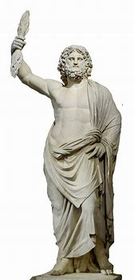

**Zeus** (Jupiter/Jove for the Romans) was the king of the gods. He was dominating, powerful and had a soft spot for pretty women. He could be terrifying when angry. His symbols were the thunderbolts, or lightning bolts made for him by the Cyclopes (his uncles); the eagle; and the scepter, or rod.

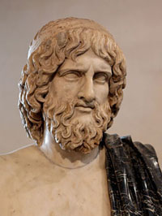

**Hades**, or Pluto, was the god of the underworld and of the dead. He was called the same names by the Romans, but they also sometimes called him Dis or Dis Pater. He was Zeus’s brother and married Persephone after kidnapping her against her will. He was gloomy and frightening.

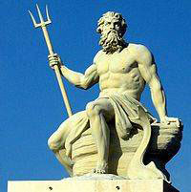

Next, we have **Poseidon,** or Neptune, as the Romans called him. He was Zeus’s brother, and he was the god of the sea and also earthquakes. He often is shown with a three-pronged spear called a trident that was made for him by his nephew, Hephaestus, and/or a fish.

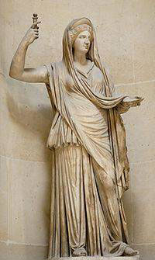

Our first goddess is **Hera.** She sits on the right side of Zeus and is his wife. Of course, she’s his sister, too, but that’s the way it was on Olympus. Hera’s Roman name is Juno, and she is the queen of the gods. She is the guardian of marriage and was well-loved by the Greeks; it’s ironic that she’s the goddess of marriage but her own marriage was so bad. She was often jealous of her husband’s affairs and could be cruel to his lovers, even the ones who didn’t want anything to do with him, but she could be tender and loving as well. The peacock was her symbol. In fact, the circles in a peacock’s tail are said to be the eyes of her 100-eyed servant, Argus.

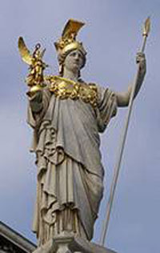

Next is **Athena**, or Minerva (Roman), the daughter who sprang fully formed from the head of Zeus after a major headache. She is the goddess of wisdom and war and also the protector and namesake of the city of Athens. She preferred reason to violence unless she was pushed. She turned Arachne into a spider for bragging that she could spin better than Athena. She was very competitive and is often pictured with her helmet and a spear. She carried Zeus’s shield, called the aegis. The owl was her bird.

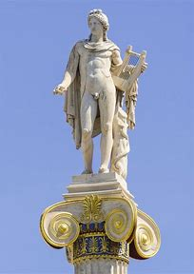

**Apollo** was a twin. His Roman name was the same as his Greek name. He was the god of the sun or light, poetry, music and medicine and was famous for his oracles (wise women to whom he gave his power to predict and interpret the future). He was very proud and also protective of his mother and sister. His symbols were the gold bow and arrows, and he often appears golden and shining. He wears a laurel wreath in memory of Daphne, who didn’t want to be his lover and prayed to Mother Earth for help escaping him; she was turned into a laurel tree.

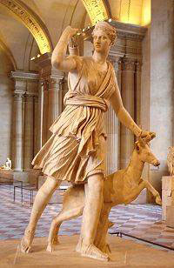

**Artemis** was Apollo’s twin. Her Roman name was Diana, and she was the goddess of hunting, chastity and the moon. She protects women and small children, is fiercely independent and particularly dislikes men. In pictures, she is seen accompanied by three hunting hounds, a bow and a fawn.

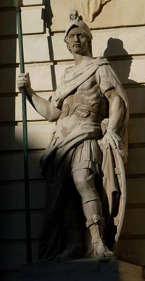

**Ares** or, as he is known by his Roman name, Mars, was the god of war. He would fight on both sides, if possible. He was young, strong and handsome, and liked to dress in battle clothes even when he wasn’t fighting.

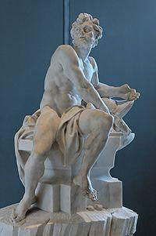

**Hephaestus**, or Vulcan, was born lame and was further crippled when he was thrown from Olympus by his mother, Hera, in a rage. He was the only Olympian with a disability. He was unhappily married to Aphrodite and worked as a blacksmith in the gods’ forge.

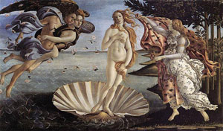

Hephaestus’s wife, **Aphrodite,** whose Roman name was Venus, was the goddess of love and beauty. She was born out of sea foam when the blood of Uranus dropped into the ocean. She was the mother of Eros and was irresistibly charming, fickle, vain and competitive. Her symbol was a cestus, or magic belt, that made everyone fall in love with the wearer; sometimes she would lend it to humans. This is a famous painting of the birth of Venus, or Aphrodite, by Botticelli.

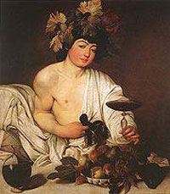

**Dionysus** was the partier of the mountain retreat. He was Zeus’s son by another woman, who was driven crazy by Hera and her jealousy. Dionysus went all around teaching people how to make wine and having a good time. Eventually, Hestia gave up her throne for him, and he lived on Olympus. He was the god of wine, of course, and also vegetation.

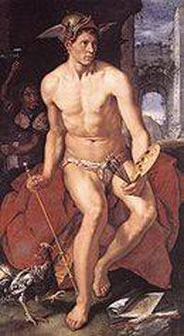

**Hermes,** or Mercury, was the god of science and invention, but he is best known as the messenger of the gods. He is often pictured with a winged helmet and sandals. He is said to have invented the alphabet, boxing and gymnastics! In this painting by Goltzius, you can see his helmet with wings; he’s not wearing his famous sandals, though.

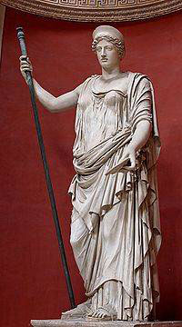

**Demeter** was the goddess of the crops and the harvest. She is also known as Ceres (Roman) and sometimes Deo. Her symbols include a torch, a crown, a scepter and stalks of grain. She is often portrayed with her daughter, Persephone, who was kidnapped by Hades and taken to the underworld. By the time she was rescued, she’d eaten six pomegranate seeds, so she couldn’t escape the underworld entirely. Her mother was so frantic that winter draped the land, and no crops would grow. A deal was struck, and Persephone was allowed to return to her mother for half of the year. So, each year, when she returns to the underworld, autumn comes, then winter — but when she returns to her mother, spring and summer come again.

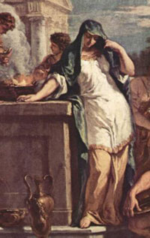

**Hestia** was Zeus’s sister and the goddess and protectress of hearth and home. She is also known by her Roman name, Vesta. She was gentle and kind and was very popular with the Greeks. She didn’t have a lot of adventures, so she’s rarely pictured in art.

**Olympians quiz**

Time to test yourself — and beware, answers may be used more than once!

[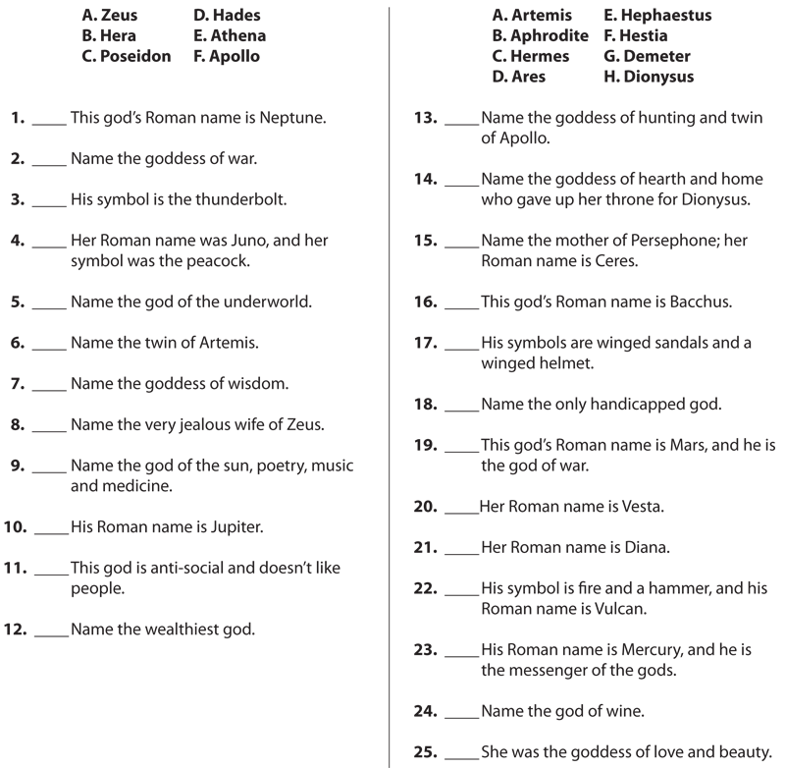](https://static.americanmensa.org/Assets/MFK2/assets/Image/Teach/LessonPlans/Lesson_Mythology-9.png)

1. **If you could have dinner with one god or goddess, who would it be and why?**
2. **Which god or goddess do you think would make the best president and why?**
3. **Imagine that Zeus has come to you and said that Olympus is lacking a god or goddess, and he needs you to help. Invent a new Olympian and describe him or her below.**
4. **Read the following sources-what might they tell us about how the gods were seen in Ancient Greece?**

Herodotus, *Histories* 2.53

“But it was – if I may so put it – the day before yesterday that the Greeks came to know the origin and form of the various gods, and whether or not all of them had always existed; for Homer and Hesiod are the poets who composed theogonies and described the gods for the Greeks, giving them their appropriate titles, offices, and powers.”

Homeric Hymn 11

“Protectress of cities, that fearsome goddess who cares with Ares for warlike works – the sacking of cities, the scream of battle, the clash of the fray – and also ensures the army’s safe parting and homeward return.”

Homer, *Odyssey* 5.383-387

“She checked all the other winds in their courses, bidding them calm down and go to sleep. She summoned the strong North Wind with which she flattened the waves in the swimmer’s path, so that Odysseus, favourite of Zeus, might be rescued from the jaws of death.”

Hesiod, *Works and Days* 338-341

“Appease the immortal gods with libations and burnt offerings, both when you go to bed and when the holy light returns, so that they may have a gracious heart and spirit towards you, and you may buy other men’s land and not have someone else buy yours.”